Assignment – 3 (AI in Finance)

By: Viren Varma

**Selected Variables and Explanations for Bankruptcy Prediction**

1. **Total Assets (at)**  
   Description: Represents the total assets of a company, reflecting the company's size and financial health.  
   Metric: Used to calculate ratios such as Debt-to-Assets and Return on Assets.
2. **Total Liabilities (lt)**  
   Description: Indicates total liabilities, crucial for understanding the company's debt burden.  
   Metric: Debt-to-Equity ratio, Debt-to-Assets ratio.
3. **Common Equity (ceq)**  
   Description: Measures the value of shareholders' equity, reflecting the company's net worth.  
   Metric: Debt-to-Equity ratio.
4. **Common Shares Outstanding (csho)**  
   Description: Represents the number of shares outstanding, aiding in per-share value calculations.  
   Metric: Earnings per Share (EPS).
5. **Total Revenue (revt)**  
   Description: Measures total revenue generated by the company, essential for profitability metrics.  
   Metric: Profit Margin, Revenue Growth.
6. **Cost of Goods Sold (cogs)**  
   Description: Shows the direct costs attributable to the production of goods sold, critical for margin analysis.  
   Metric: Gross Profit Margin.
7. **Selling, General, and Administrative Expenses (xsga)**  
   Description: Tracks overhead expenses, important for analyzing operating efficiency.  
   Metric: Operating Margin.
8. **Net Income (ni)**  
   Description: Indicates profitability after all expenses, crucial for assessing overall performance.  
   Metric: Profit Margin, Return on Equity.
9. **Operating Cash Flow (oancf)**  
   Description: Measures cash generated from operations, highlighting the company's ability to generate cash.  
   Metric: Cash Flow to Debt Ratio.
10. **Capital Expenditures (capx)**  
    Description: Indicates investment in capital assets, used to assess the company's reinvestment strategy.  
    Metric: Capital Expenditure Ratio.
11. **Earnings Before Interest and Taxes (ebit)**  
    Description: Reflects the core operational profitability before financial costs.  
    Metric: Interest Coverage Ratio.
12. **Earnings Before Interest, Taxes, Depreciation, and Amortization (ebitda)**  
    Description: Assesses operating performance by eliminating non-operational factors.  
    Metric: EBITDA Margin.
13. **Long-Term Debt (dltt)**  
    Description: Represents long-term obligations, crucial for assessing financial leverage.  
    Metric: Debt-to-Equity, Long-Term Debt Ratio.
14. **Current Debt (dlc)**  
    Description: Short-term liabilities, essential for liquidity and short-term solvency analysis.  
    Metric: Current Ratio.
15. **Current Assets (act)**  
    Description: Measures assets expected to be converted into cash within a year.  
    Metric: Current Ratio, Quick Ratio.
16. **Current Liabilities (lct)**  
    Description: Represents short-term obligations due within a year.  
    Metric: Current Ratio, Quick Ratio.
17. **Short-Term Investments (ivst)**  
    Description: Measures investments that can be easily liquidated.  
    Metric: Cash Ratio.
18. **Other Investments (ivao)**  
    Description: Tracks long-term investments not part of operations, relevant for evaluating asset quality.  
    Metric: Total Investment to Assets Ratio.
19. **Cash and Cash Equivalents (capr1)**  
    Description: Tracks liquid cash, important for liquidity analysis.  
    Metric: Cash Ratio.
20. **Property, Plant, and Equipment Gross (ppegt)**  
    Description: Represents investment in fixed assets.  
    Metric: Asset Turnover Ratio.
21. **Goodwill (gdwl)**  
    Description: Measures the value of acquired intangible assets, relevant for assessing asset quality and impairment risks.  
    Metric: Goodwill to Assets Ratio.
22. **Intangible Assets (intan)**  
    Description: Reflects non-physical assets, crucial for evaluating long-term value creation potential.  
    Metric: Intangible to Total Assets Ratio.
23. **Deferred Taxes (txdb)**  
    Description: Represents taxes delayed for future payment, highlighting potential future liabilities.  
    Metric: Deferred Tax Ratio.
24. **Interest Expense (xint)**  
    Description: Measures the cost of borrowed funds, critical for understanding financial risk and leverage.  
    Metric: Interest Coverage Ratio.
25. **Working Capital (wcap)**  
    Description: Represents the difference between current assets and current liabilities, a key measure of operational liquidity.  
    Metric: Working Capital to Assets Ratio.

**Correlation Matrix:**

**Highly Correlated Pairs of Variables**

Operating Margin and EBITDA Margin  
Correlation: 1.00  
Total Assets (at) and Total Liabilities (lt)  
Correlation: 1.00  
Current Ratio and Quick Ratio  
Correlation: 0.99  
Debt-to-Assets and Working Capital to Assets  
Correlation: -0.98  
Goodwill (gdwl) and Intangible Assets (intan)  
Correlation: 0.92  
Total Revenue (revt) and Cost of Goods Sold (cogs)  
Correlation: 0.92  
Capital Expenditures (capx) and Depreciation (dp)  
Correlation: 0.84  
Accounts Payable (ap) and Cash Equivalents (che)  
Correlation: 0.82  
Goodwill to Assets and Intangible to Total Assets  
Correlation: 0.80

The analysis reveals several key points:

Operating Margin and EBITDA Margin  
Correlation: 1.00  
Indicating they provide similar information. I retained only one using PCA to avoid redundancy.

Total Assets and Total Liabilities  
Correlation: 1.00  
Reflecting the fundamental accounting equation. I choose one using PCA to avoid multicollinearity.

Current Ratio and Quick Ratio  
Correlation: 0.99  
Both measure liquidity, but the Quick Ratio is more stringent. I included only one to streamline the model.

Debt-to-Assets and Working Capital to Assets  
Correlation: -0.98  
This inverse relationship suggests that as debt increases, working capital relative to assets decreases. Including both might be redundant.

Goodwill and Intangible Assets  
Correlation: 0.92  
Indicating they often vary together. I considered including only one to reduce redundancy.

Total Revenue and Cost of Goods Sold  
Correlation: 0.92  
This relationship is typical and is noted as COGS typically scales with revenue.

Capital Expenditures and Depreciation  
Correlation: 0.84  
Reflecting that higher capital expenditures lead to increased depreciation.

Accounts Payable and Cash Equivalents  
Correlation: 0.82  
Suggesting that changes in cash are closely linked to accounts payable.

Goodwill to Assets and Intangible to Total Assets  
Correlation: 0.80  
Indicating they move together in relation to asset values.

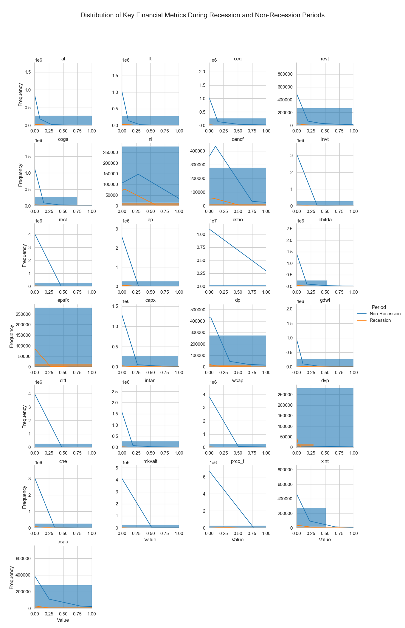

Across most variables, such as total assets (at), liabilities (lt), and common equity (ceq), there remains a strong concentration near smaller values, with a sharp decline as the values increase. This pattern suggests that most firms operate at a moderate scale, while only a few reach the higher financial thresholds. Notably, the distribution for net income (ni) shows a more pronounced difference between recession and non-recession periods, with recession periods exhibiting a tighter, more negative distribution, indicative of the financial strain firms experience during economic downturns.

The cross-sectional analysis shows that even though many variables, such as cash flow from operations (oancf) and capital expenditures (capx), exhibit right-skewed distributions, the difference between recession and non-recession periods remains subtle for most variables, except for those directly impacted by economic contractions. Variables like net income and dividends paid (dvp) demonstrate clearer shifts during recession periods, where firms face more significant challenges. Overall, the changes across periods reflect the resilience of most firms, with only a few key metrics showing distinct stress during recessions.

PCA: Reduced to 10 variables

